**Name: Mohammad Awais**

**Class: BSCS-8-A**

**CMS: 242554**

# Compiler Construction Lab 12

## Task 1 ( Install LLVM ):

* **Installing LLVM using apt-get, first update apt-get.**

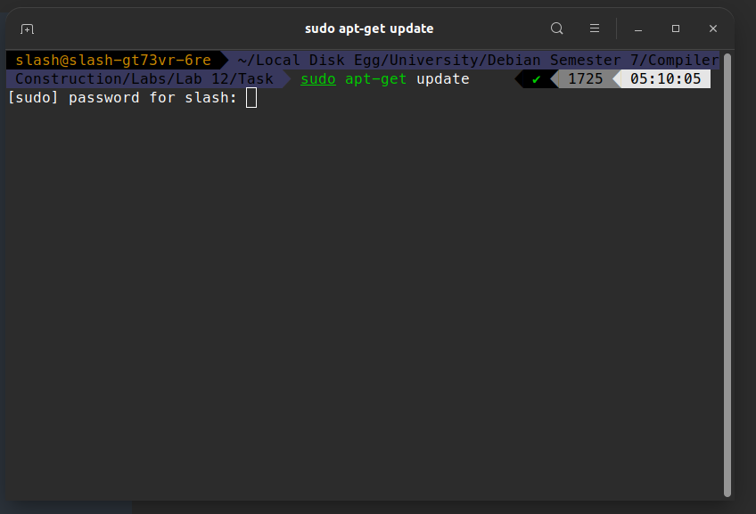

* **Installing LLVM with command “ *sudo apt-get -y install llvm* ‘**

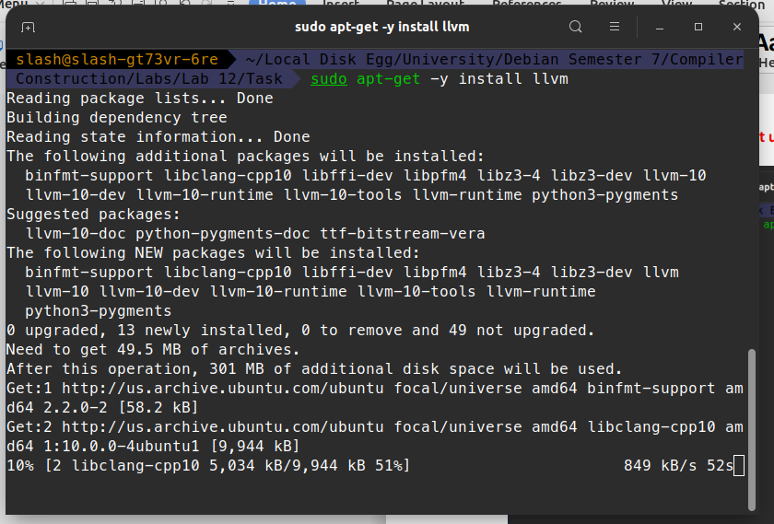

* **Checking if installed by “ apt-cache policy llvm ‘**

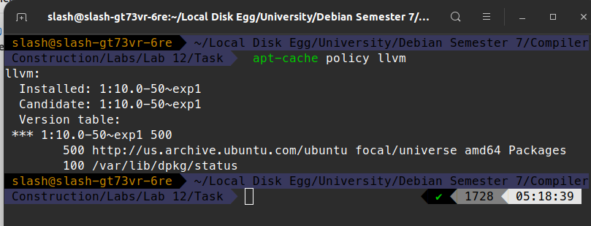

**NOTE: NO NEED TO CONFIGURE AND COMPILE AS APT-INSTALLED**

* **Installing clang12 as not exists:**

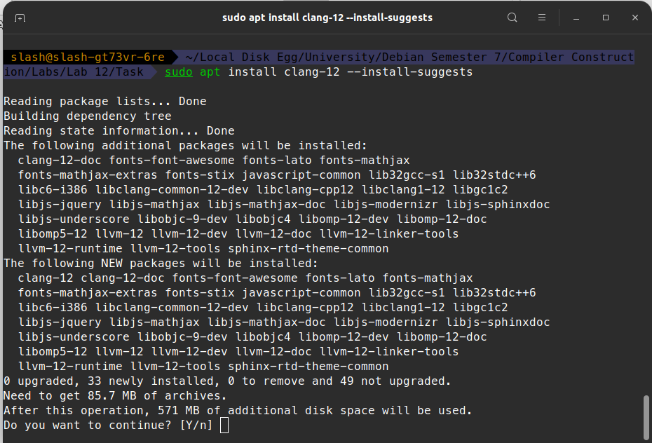

* **Check if installed:**

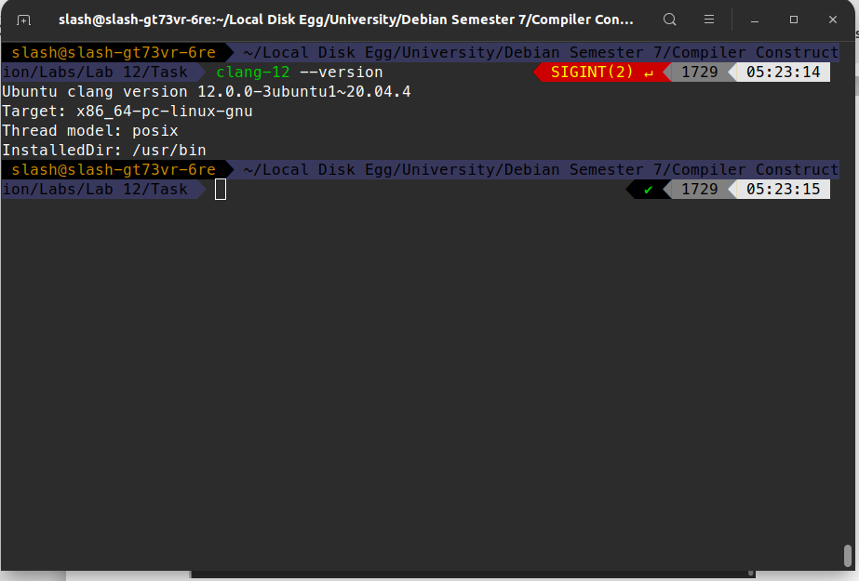

## Task 2 ( LLVM Code ):

* **Created “ *task1.c* “ with code given:**

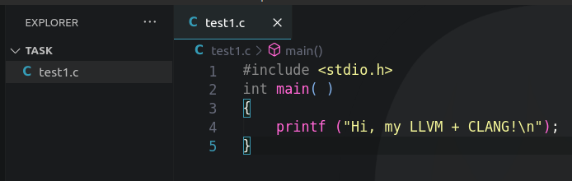

* **Compiling using clang (native code) and running it:**

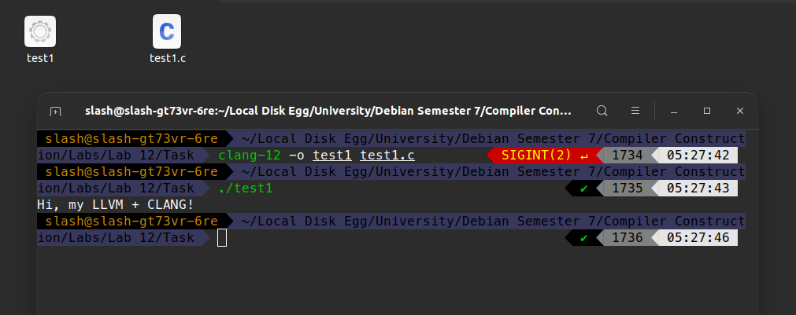

* **Generate LLVM IR (Assembly Form) using following command:**

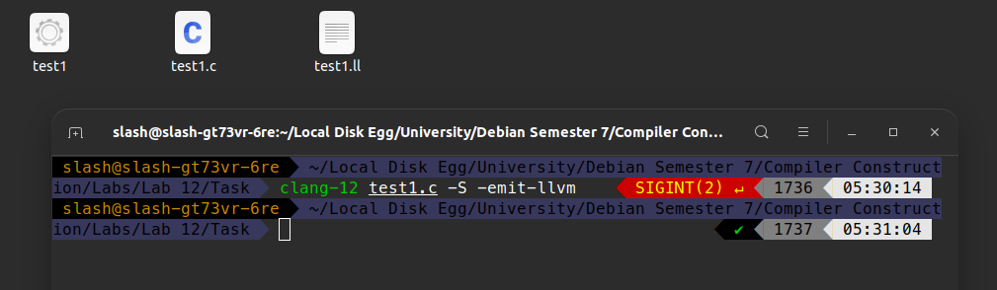

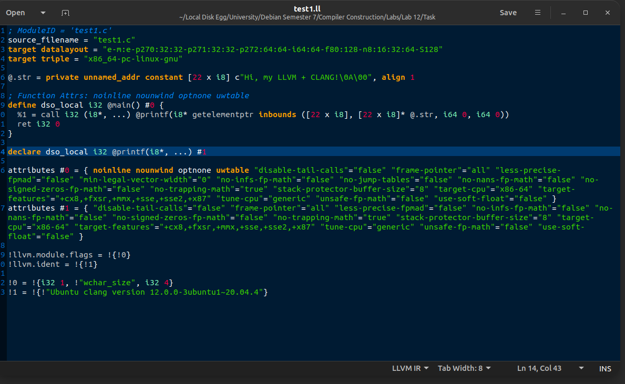

* **Running same command with optimization flag:**

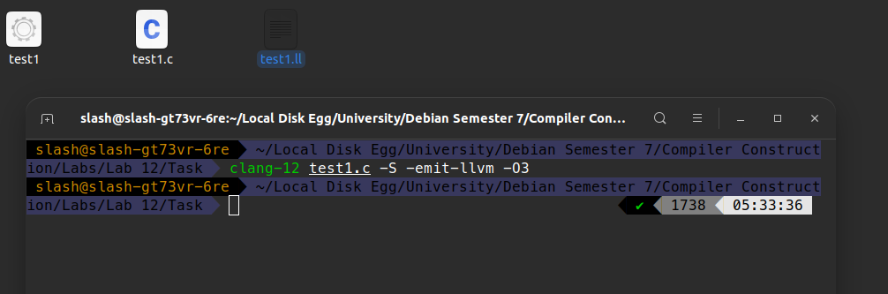

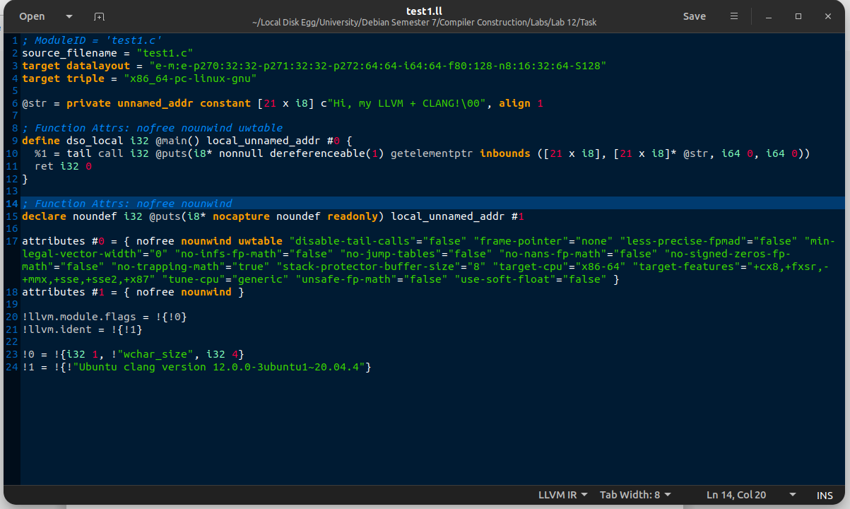

**Difference : Optimized code have some other functions used like “Puts” in place of “print” , etc. In DSOLOCAL**

* **Doint the same for another code:**

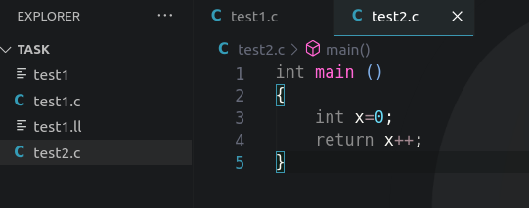

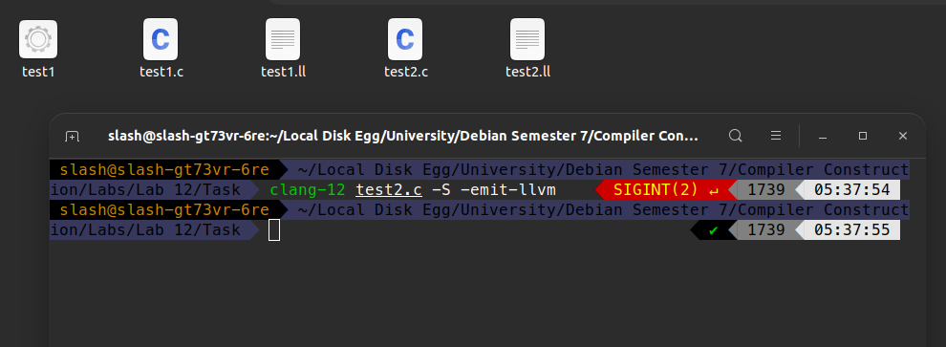

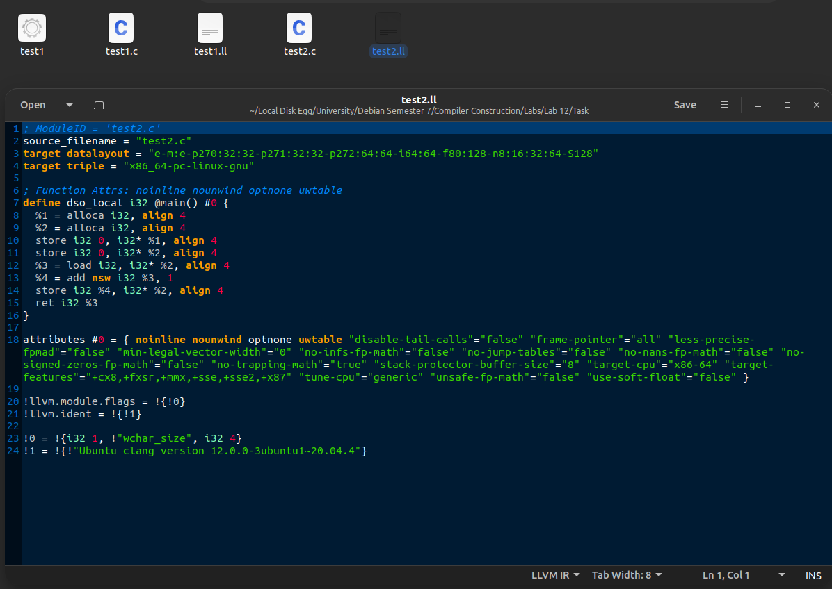

**AND NOW OPTIMIZED :**

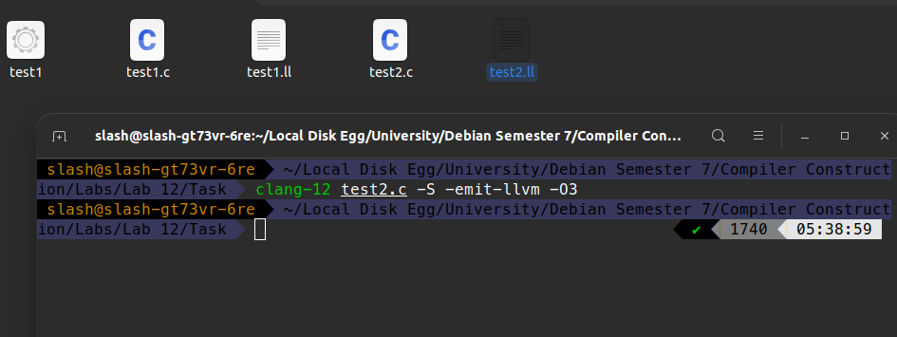

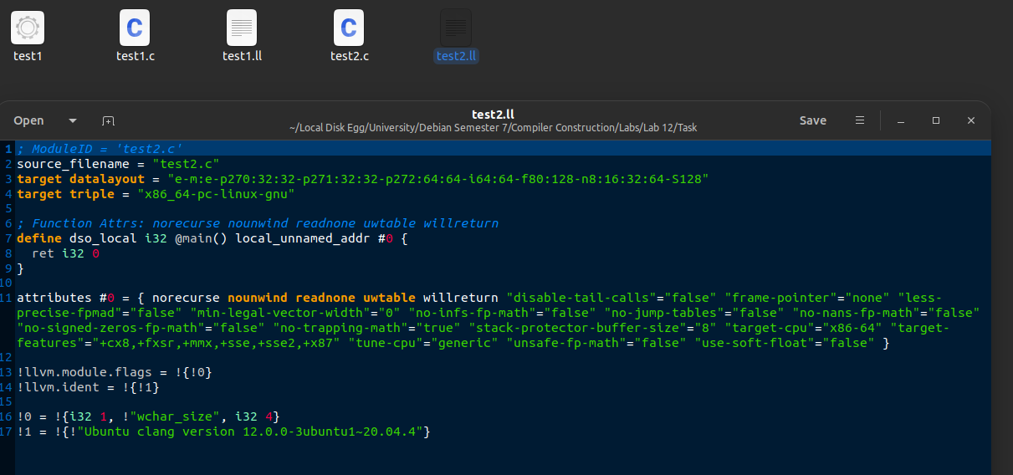

**Difference : As noticed here, Optimized Code has only one line in dso_local whereas there’s many in non-optimized Code**